2026 MORRIS CITY BUSINESS BANNER PROGRAM
The Morris Business Banner Program is a great way to bring people to your business, show Morris pride, support the business-building efforts of the Chamber and provide a great return on your investment.

Please read below for complete Terms and Conditions. Space is limited! Reserve your banner(s) today. Orders and logos due by April 15.
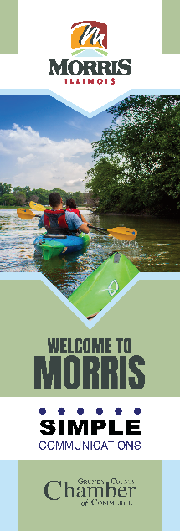
PROGRAM GUIDELINES
-Both Chamber members and non-members can participate.
-Banners measure 53 x 18.”
-Banner construction is of rip-stop double vinyl print.
-Company name or logo is printed on the bottom 35% of the banner.
-Eligible poles line downtown Morris on Liberty Street and on side streets.
-Price includes banner, hardware, installation and maintenance for a 12-month period.
-Banner location requests cannot be guaranteed and have to be approved.
-Banners will be placed on a first-come, first-served basis.

ART GUIDELINES
-Business to provide a high-resolution logo or all info in one format. (For ex. Logo with phone number in one jpg format). The other option is no logo and provide text limited to 2 lines.
-Square-shape or 2-color logos look best.
-For text users, we recommend business name and phone or website only.
-All text will be printed in standard Arial font.
-Artwork must accompany your application. Please email all logos to info@grundychamber.com in EPS/Vector (preferred), PDF, or JPG.
Sample banner
18 inches

ORDER FORM
MEMBER ORDERS NON-MEMBER ORDERS
Qty 1 @ $275 = $ 275 Qty ____ @ $375 each = $ __________
Qty (2 or more) ___ @ $250 each = ____ Consider membership! Contact us at 815-942-0113.

Company: _________________________________________ Contact: ___________________________________

E-mail: ___________________________________________ Phone: ____________________________________

Please choose one: ___ Logo for banner. (Email logo to info@grundychamber.com) ___ Text for banner (limited to 2 lines):

Text Line 1. ____________________________________ Text Line 2. __________________________________
Only if not using a logo.
TERMS & CONDITIONS
I understand that by signing below, I have agreed to the program and art guidelines as stated above. I understand that the banner image or text submitted with this application is subject to minor alterations. I understand that fees paid will cover banner production and sponsorship for a term of one year. I further understand that the Chamber reserves the right to limit the quantity and placement of banners.

Signed _______________________________________________ Date ________________________________

Printed Name _________________________________________
Payment Method:

❑ Cash
 Check (payable to Grundy County Chamber) Ck# ____________
 Credit Card ___ MC ___ Visa ___ Discover

Card # _____________________________________________________

Name on Card _______________________________________________

Exp. Date____________ Zip Code ___________
Payment must be included at time of application.
Poles will not be reserved until payment is received. Please return with payment to:
Grundy County Chamber of Commerce & Industry
909 Liberty Street, Morris, IL 60450

Office Use Only: Date Rec’d _______________ Amt $ ____________

Artwork Rec’d __________ Proof _________Pole(s) ______________

By _________ Comments ___________________________________
Office Use Only: Date Rec’d ______________ Ck# ______________

Total $ _______________ Dues $ ______________ Fees $ ____________

Sponsorship Total $ _______________ Program Total $ ______________
Office Use Only: Date Rec’d ______________ Ck# ______________

Total $ _______________ Dues $ ______________ Fees $ ____________

Sponsorship Total $ _______________ Program Total $ ______________

